**LIST OF NAMED COLORS SUPPORTED IN MATPLOTLIB**

Matplotlib provides a wide range of colors that you can use to plot your graphs. Here are some of the common ways to specify colors in Matplotlib:

1. **Base Colors:** Matplotlib defines a set of base colors that you can use by name as well as alias name.

* Blue : b
* Green : g
* Red : r
* Cyan : c
* Magenta : m
* Yellow : y
* Black : k
* White : w

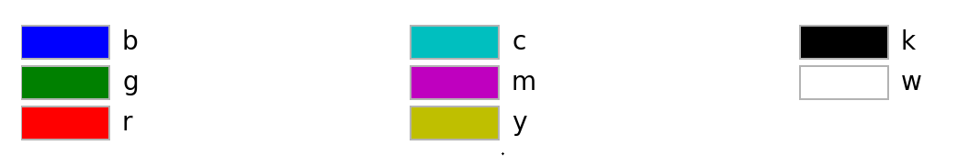

1. **Tableau Colors:** There are ten colors in the Tableau palette. Here, you specify the color like this **tab:color**.

Following are the ten colors that come under the Tableau palette:

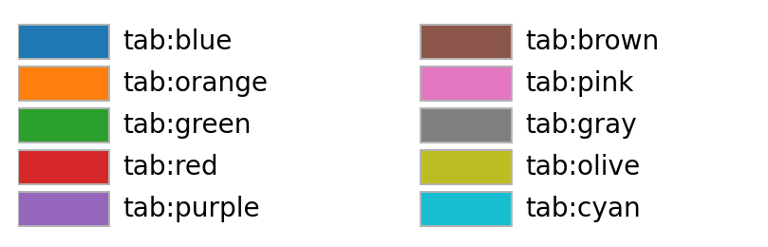

1. **CSS color names:** Matplotlib also supports a number of CSS color names, which are based on the 147 named colors defined in the HTML and CSS standards.

Following are the 147 named colors supported for Matplotlib:

|  |  |  |
| --- | --- | --- |
| aliceblue | antiquewhite | aqua |
| aquamarine | azure | beige |
| bisque | black | blanchedalmond |
| blue | blueviolet | brown |
| burlywood | cadetblue | chartreuse |
| chocolate | coral | cornflowerblue |
| cornsilk | crimson | cyan |
| darkblue | darkcyan | darkgoldenrod |
| darkgray | darkgrey | darkgreen |
| darkkhaki | darkmagenta | darkolivegreen |
| darkorange | darkorchid | darkred |
| darksalmon | darkseagreen | darkslateblue |
| darkslategray | darkslategrey | darkturquoise |
| darkviolet | deeppink | deepskyblue |
| dimgray | dimgrey | dodgerblue |
| firebrick | floralwhite | forestgreen |
| fuchsia | gainsboro | ghostwhite |
| gold | goldenrod | gray |
| grey | green | greenyellow |
| honeydew | hotpink | indianred |
| indigo | ivory | khaki |
| lavender | lavenderblush | lawngreen |
| lemonchiffon | lightblue | lightcoral |
| lightcyan | lightgoldenrodyellow | lightgray |
| lightgrey | lightgreen | lightpink |
| lightsalmon | lightseagreen | lightskyblue |
| lightslategray | lightslategrey | lightsteelblue |
| lightyellow | lime | limegreen |
| linen | magenta | maroon |
| mediumaquamarine | mediumblue | mediumorchid |
| mediumpurple | mediumseagreen | mediumslateblue |
| mediumspringgreen | mediumturquoise | mediumvioletred |
| midnightblue | mintcream | mistyrose |
| moccasin | navajowhite | navy |
| oldlace | olive | olivedrab |
| orange | orangered | orchid |
| palegoldenrod | palegreen | paleturquoise |
| palevioletred | papayawhip | peachpuff |
| peru | pink | plum |
| powderblue | purple | red |
| rosybrown | royalblue | saddlebrown |
| salmon | sandybrown | seagreen |
| seashell | sienna | silver |
| skyblue | slateblue | slategray |
| slategrey | snow | springgreen |
| steelblue | tan | teal |
| thistle | tomato | turquoise |
| violet | wheat | white |
| whitesmoke | yellow | yellowgreen |